11 Chemistry - Organic Naming Practice

Name: ____________________ Date: ________________

Name the following structures using IUPAC nomenclature.

1.
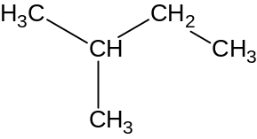 ___________________________

2.
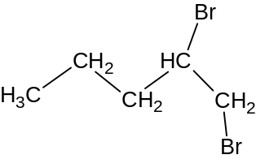 ____________________________

3.
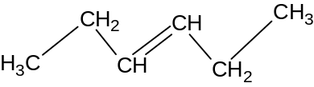 _____________________________

4.
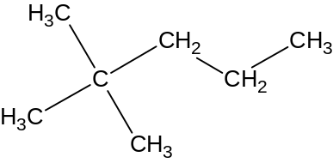 ______________________________

5.
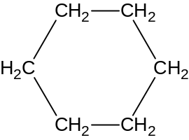 _______________________________

6.
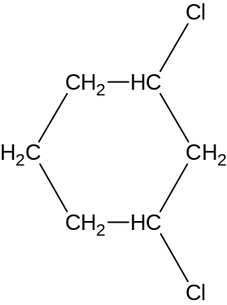 ________________________________

7.
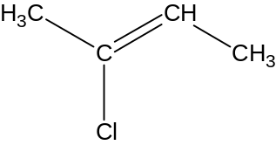 _______________________________

8.
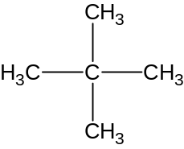 ________________________________

9.
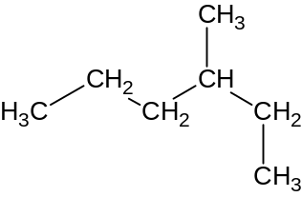 _________________________________

10.

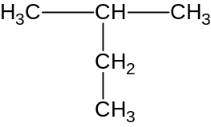 _________________________________

11.
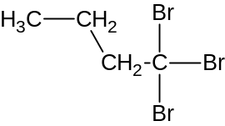 __________________________________

12.
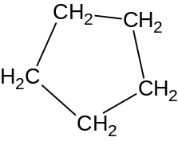 __________________________________

13.
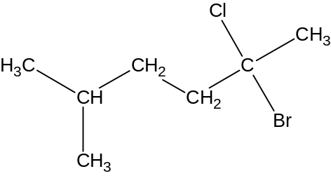 ___________________________________
Answers
1. 2-methylbutane
2.

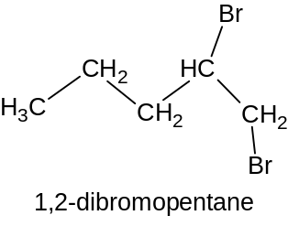

3. 3-hexene
4.
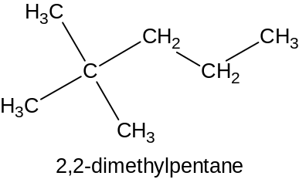

5.
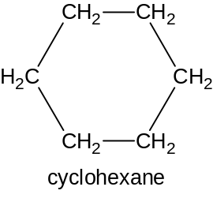

6.
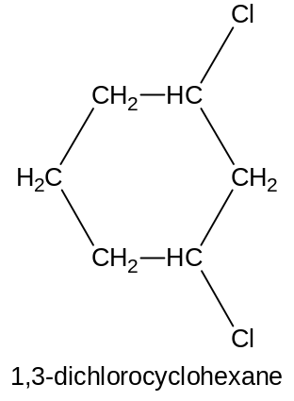

7. 2-chloro-2-butene
8. 2,2-dimethylpropane

9.
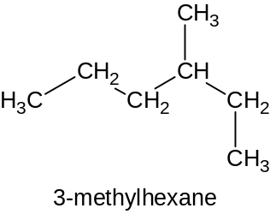
10. 2-methylbutane
11. 1,1,1-tribromobutane
12. cyclopentane
13.
